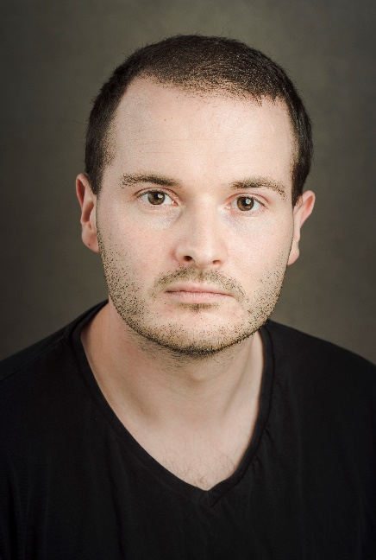
Frank Harvey
07854252648
f.harvey69@hotmail.com
Playing age: 26-36
Height: 5’11”
Location: West Wales, Pembrokeshire
Accent: Kent (Native)
Voice: Clear, Variable.

Production Role Venue/Company Director

TV

‘World’s Most Evil Killers’ Karol Kot Woodcut Media Andy
Papadopoulos

‘Wings of War’ Sir Frank Whittle Woodcut Media Andy
Papadopoulos

Theatre

‘Aladdin’ Genie/Abanazar Outside the Box Productions Sinead Gibson

‘Waiting for Godot’ Vladimir Solent Productions Matt Fletcher

‘Equus’ Martin Dysart Solent Productions Matt Fletcher

‘Rosencrantz
& Guildenstern’ Guildenstern Solent Productions Mark Adams

‘The Pearl’ Father The Point Theatre Myself
(Adaptation)

Film

‘The Owl’ Getaway Driver Solent Productions Kim Morris

Experienced in - Comedy, Film, Film (Short), Film (Student), Impressionism, New Writing, Pantomime, Presenting, Radio, Theatre (Professional), Theatre (Touring), TV.

Owns – Driving license, Car.

Unions – Equity.

