Professor Richard's Fabulous Journey
It has been great to follow his fascinating journey on Instagram, the leader with the torch lighting the path of his town of writers, that is the image that remains of what he has achieved and the fascinating journey where we have virtually accompanied him.

I know perfectly well that all those who have been constant on this site will find things fabulous and enriching, I am pleased to be able to comment on it and not get lost altogether.

I also thank Amanda for her work with the questionnaire that she has sent us to enlist us again in the fascinating world of screenwriters.
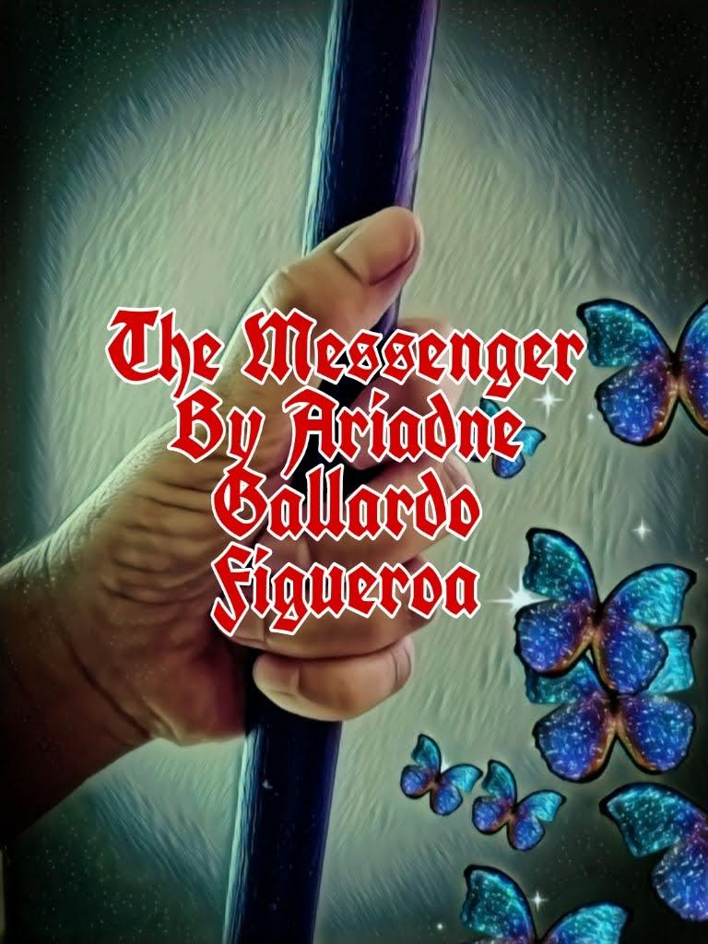
I'm with my fifth book or notebook published on Amazon since a publisher would do a better job at that than me, but what I like is what my books say and at some point, they will be read, I hope so.

I still don't know if I'm going to participate in the courses, these are times when I will finally be able to take a plane and visit my family, but somehow I remember your enthusiasm and vitality when I see a program on tv, I seek for the scriptwriters if I meet the name of one of you, with whom I have shared a part of the webinars and I send you cheers from my country.

I leave you the design of my poster with which I promoted my fourth book and I send you a virtual hug from a distance, greetings and happy omens for this year that is about to end, that good expectations and great projects become a reality for all, best regards Ariadne Gallardo Figueroa

